# Problem statement:

It is required to design the database for a Property Management System that allows a real estate company to efficiently manage properties, tenants, lease contracts, and rental payments. Additionally, the system must track maintenance requests made by tenants for specific properties they are renting.Currently. the company manages information manually using spreadsheets. which leads to frequent errors, duplication of data, and inefficiency in tracking rental contracts and payments. This results in loss of revenue, poor customer service, and compliance issues.

The company seeks to implement a digital system that will:

* Track properties and associate them with owners.
* Manage tenants and their corresponding rental contracts.
* Record payments made by tenants under each contract.
* Improve data consistency, reduce manual errors, and streamline business operations.
* Enhanced data management with no redundancies.
* Easier tracking of contract renewals, expirations, and payments.
* Better financial management with payment histories tied to tenants and proper-ties.

# ER Diagram:

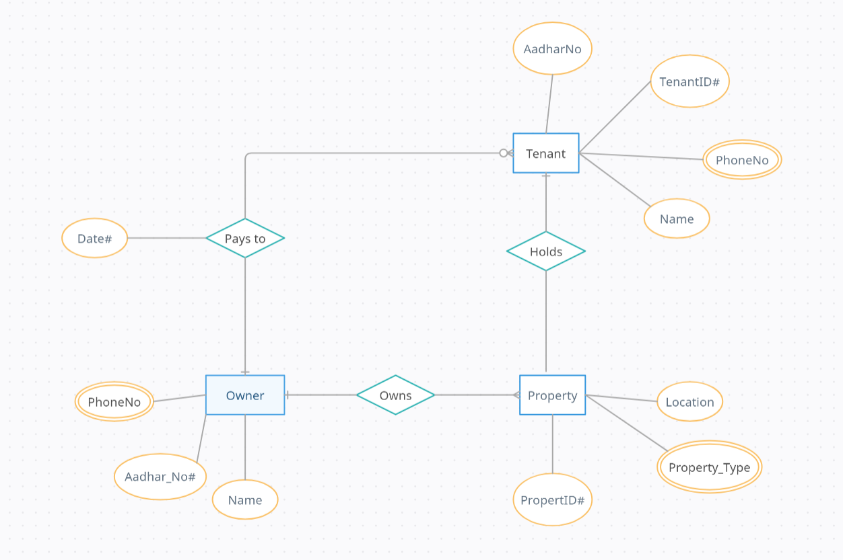

Figure 1 – Entity Relationship Diagram

Source: <https://app.creately.com>

Steps to follow:

1. **Sign up/log in** to Creately at [app.creately.com](https://app.creately.com).
2. Click "**Create New**" and choose "**Blank Diagram**" or "**ER Diagram**" template.
3. Drag Entity shapes (rectangles) from the left toolbar for each table (e.g., OWNER, PROPERTY).
4. Double-click entities to name them (e.g., OWNER).
5. Add attributes (columns) inside entities (e.g., AADHAR, NAME).
6. Label primary keys (PK) by underlining or marking with (PK).

Use lines to connect entities, showing relationships (e.g., OWNER → PROPERTY).

1. Label relationships (e.g., "**Has**", "**Belongs** **to**").
2. Specify cardinality using symbols like crow’s foot for one-to-many.
3. Customize diagram with colors, fonts, and line styles.
4. Adjust layout for clarity and readability.
5. Save the diagram within your account.
6. Export the diagram in PNG, PDF, or other formats (Premium feature).
7. Share via link or invite collaborators to view/edit the diagram.

# Schema Diagram:

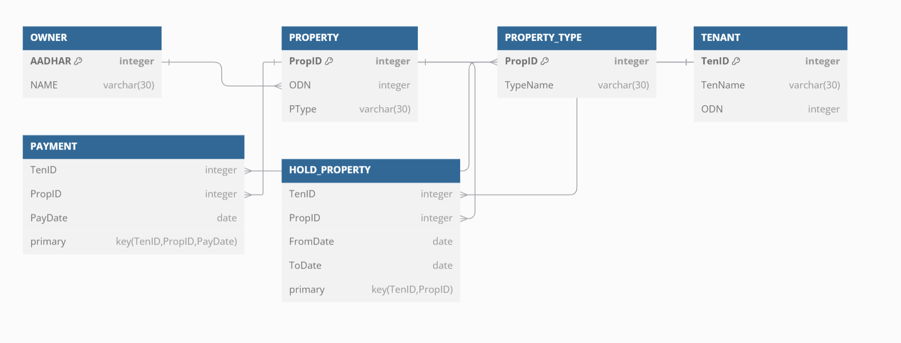

Figure 2 – Schema Diagram

Source: <https://dbdiagram.io/d>

Steps to create Schema diagram in dbdiagram.io.

1. Sign up/log in at **dbdiagram.io** to save your work or use a **Guest account**.
2. Click **"Create a new diagram"**.
3. Select **DBML format**.
4. Paste the provided **DBML code** into the editor.
5. View the **auto-generated ER diagram**.
6. **Customize** the diagram as needed.
7. **Save** the diagram.
8. **Export** the diagram in your preferred format.
9. **Share** or **collaborate** with others if needed

**DBML** code for making this schema on the above website:

Table OWNER {

  AADHAR integer [pk]

  NAME varchar(30)

}

Table PROPERTY {

  PropID integer [pk, increment]

  ODN integer

  PType varchar(30)

}

Table PROPERTY_TYPE {

  PropID integer [pk]

  TypeName varchar(30)

}

Table TENANT {

  TenID integer [pk]

  TenName varchar(30)

  ODN integer

}

Table PAYMENT {

  TenID integer

  PropID integer

  PayDate date

  // Define Composite Primary Key

  primary key(TenID, PropID, PayDate)

}

Table HOLD_PROPERTY {

  TenID integer

  PropID integer

  FromDate date

  ToDate date

  // Define Composite Primary Key

  primary key(TenID, PropID)

}

// Define Foreign Keys outside table definitions

Ref: PROPERTY.ODN > OWNER.AADHAR

Ref: PROPERTY_TYPE.PropID > PROPERTY.PropID

Ref: PAYMENT.TenID > TENANT.TenID

Ref: PAYMENT.PropID > PROPERTY.PropID

Ref: HOLD_PROPERTY.TenID > TENANT.TenID

Ref: HOLD_PROPERTY.PropID > PROPERTY.PropID